**LAB 12**

*Strings & Arrays*

**Q1) Alex wants to send his message (Password of Account) to Bob, in order to avoid that no one can understand his message he used the codewords. She only says to Bob whatever will be written in given sentence, if you flip it right to left that will be its answer. Write a program in assembly (as displayed in output) using invoke procedure.**

**Program:**

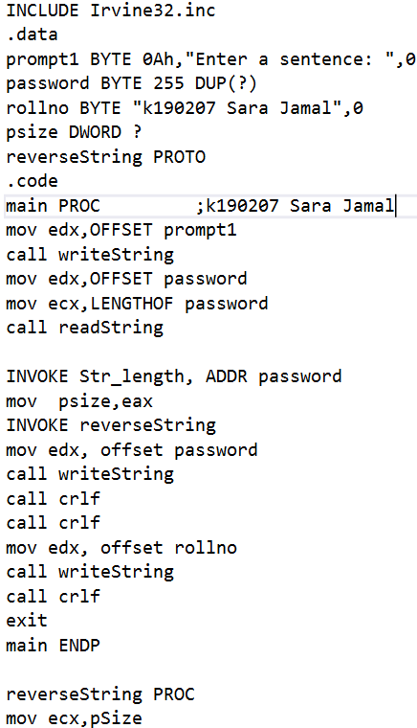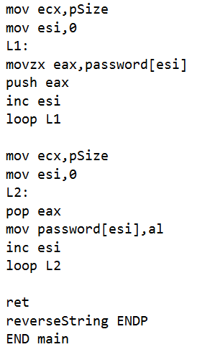

**Output:**

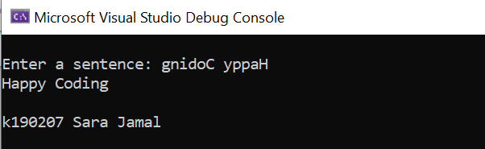

**Q2) Write a program in assembly to show following output using procedure**

**Program:**

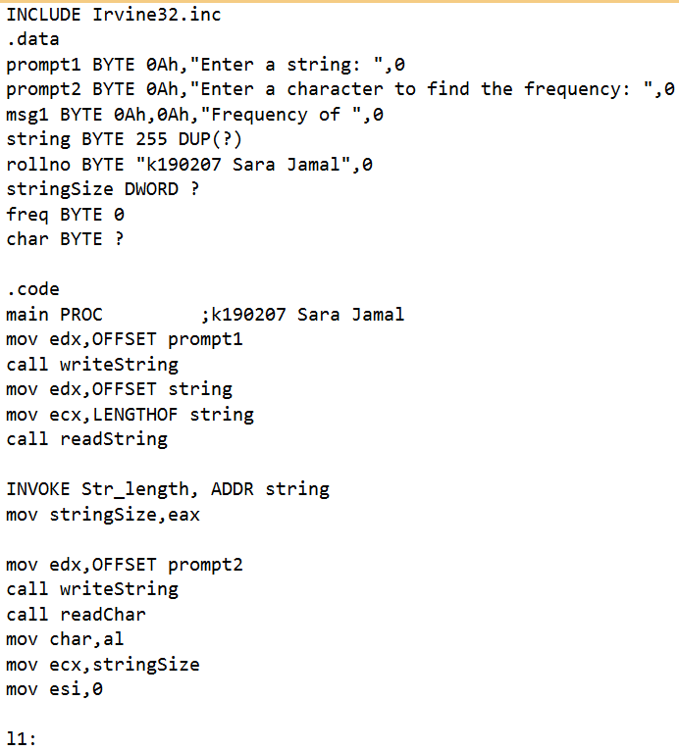

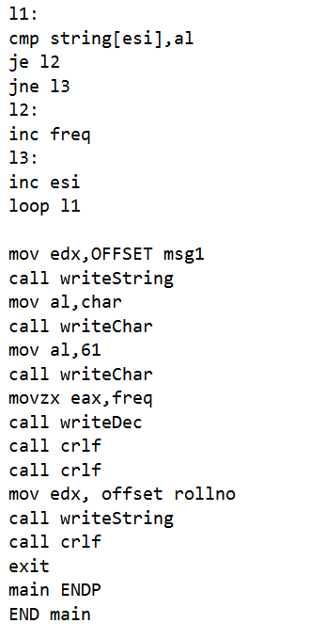

**Output:**

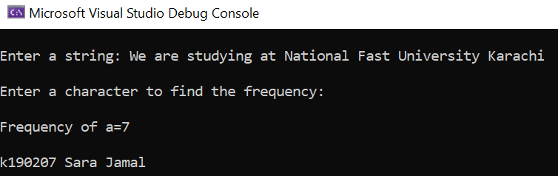

**Q3) Write a program in assembly that inputs the elements of an integer array containing 08 numbers from the user and displays the number of positive, negative and zero values and also find the sum of inputted positive and negative numbers present in an array.**

**Program:**

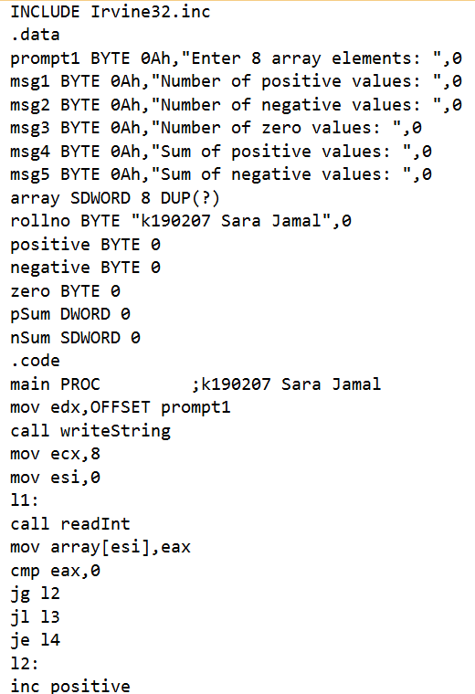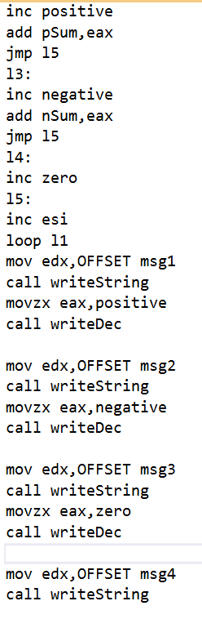

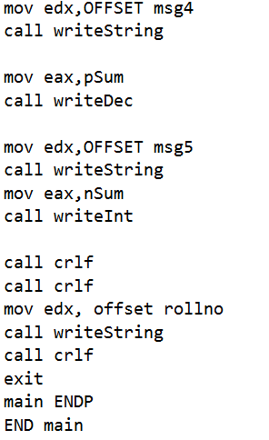

**Output:**

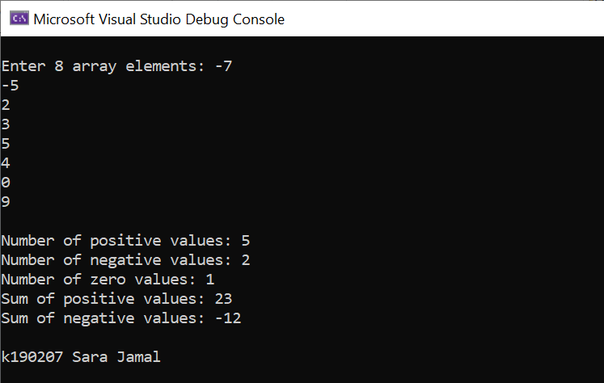

**Q4) Write a program in assembly to display all the possible diagonals of 2D Array.**

**Program:**

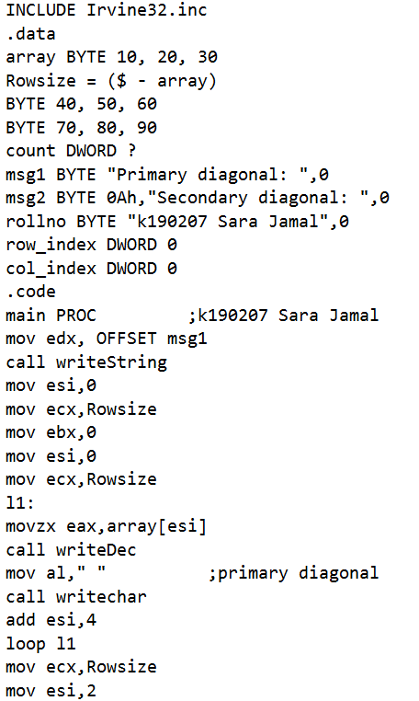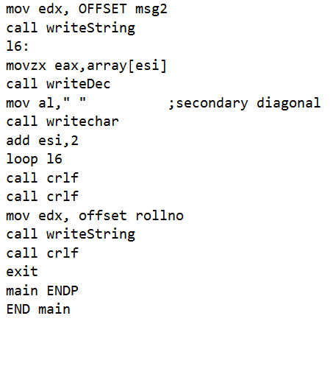

**Output:**

